***TDP Solutions***

**CSC 131: Software Engineering**

**Team Data Pirates - Section 01**

Software Requirement Specification (SRS)

*Revision History*

| ***Revision #*** | ***Revision date*** | ***Revised by*** | ***Revision(s)*** |
| --- | --- | --- | --- |
| *0.1* | *9/21* | *Ryan* | *Add cover page and insert project scope flowchart* |
| *0.2* | *9/28* | *Catalina* | *Update Section 7 with member roles and signatures* |

*Table of Contents*

1. **Introduction………………………………………………………………………………3**

1.1 Project Description

1.2 Project Scope

1. **General Description……………………………………………………………………...4**

2.1 Glossary

2.1.1 Definitions

2.1.2 Acronyms

2.2 Project Sponsor

2.3 User Characteristics

1. **Object Oriented Analysis (OOA)……………………………………………………….7**

3.1 Use Case Models (UCM)

3.2 Use Case Description

3.2.1 PDF Entry Operations

1. **System Functional Requirements……………………………………………………….8**

4.1 Functional Requirements

4.2 Non-Functional Requirements

1. **User View of Product Use………………………………………………………………..9**
2. **General Constraints and Assumptions………………………………………………..11**
3. **Team Member Roles and Approval…………………………………………………...12**

*Figures*

Figure 1.2: System Context Diagram

Figure 5.1: Fixing UI and repairing nullReference errors on original PDF document

Figure 5.2: Dropdown menu with autofill demonstration

Figure 5.3: Importing images into the PDF

1. **Introduction**

1.1 Project Description

* CT PDF Management Tool
* This PDF tool allows for expedited document creation, editing, and sharing of various CalTrans PDF files via various automated processes including the following:
* Autofill
* Auto-suggestions for repetitive information
* Modern UI
* PDF Generation
* Autosave

1.2 Project Scope

* Our project executes functions from an external Apache API and uses an integrated compiler on Apple devices such as iPads/iPhones to automatically convert code to its proper format and provide a solid foundation upon which PDF files can be edited, saved, and shared.
* The System Context Diagram as shown (**Figure 1.2**) displays a diagram of the general flow of the program. Beginning at the user, they enter new data, the program sends Java code to be compiled into iOS compatible code using the Apache library. It then sends this parsed data to the PDF document which, when saved, displays it to the device.

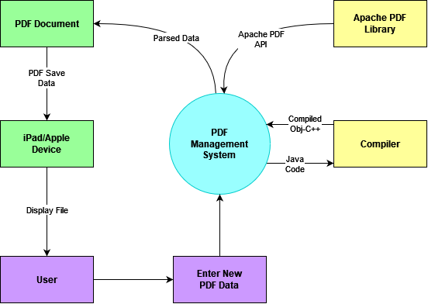

**2. General Description**

The following serves as a general description of our product and its purpose is to give the reader an “executive overview.” Furthermore, the following is user-oriented.

**2.1** **Glossary**

For the convenience of the user, we’ve entailed the preceding subsections which define the terms, and acronyms used within this document.

**2.1.1 Definitions**

*Actor* A coherent set of roles that users of use cases play when interacting with these use cases; represents anything that interacts with the system.

*Abstraction* A simplified representation of something that is potentially quite complex.

*Attribute* A description of the characteristics of the object; usually appears in OOA as adjectives.

*Class* A description of a set of objects that share the same attributes, operations, relationships, and semantics.

*Client* An occupant of Caltrans.

*Entity* A data object; producer/consumer of information outside the bounds of the system.

*Incremental* Recording method allowing subsequent append or overwrite operations without reformatting or loss of adjacent pre-recorded information.

*Intranet* A private network inside a company or organization that uses the same kinds of software that you would find on the public Internet, but only for internal use.

*Method* A function (subroutine) associated with an object; usually appears in OOA as verbs.

*Object* Referring to a software object, correlates to real-world objects in that they, too, have state and behavior; usually appears in OOA as nouns; An instance of a class.

*Use Case* A sequence of actions, including variants, that a system (or other entity) can perform, interacting with actors of the system.

*User* As pertains to the client-side of a client/server connection.

*Workstation* A computer connected to a network at which users interact with software stored on the network.

​​**2.1.2** **Acronyms**

*PMS* PDF Management System

*CSV* Comma Separated Values

*HTML* Hyper-Text Markup Language

*HUD* Housing & Urban Development

*HW* Hardware

*LAN* Local Area Network

*N/A* Not/Non Applicable

*OOA* Object Oriented Analysis

*PC* Personal Computer

*SRS* Software Requirement Specification

*SW* Software

*TBD* To Be Determined

*UML* Unified Modeling Language

*OBJCP* Objective-C++ Language

**2.2 Project Sponsor**

**SWPPP** – Stormwater Pollution Prevention Plan; This is a Stormwater Management Plan developed and implemented by the contractor for projects over 1 acre of soil disturbance.

**WPCP** – Water Pollution Control Program; This is a Stormwater Management Plan developed and implemented by the contractor for projects under 1 acre of soil disturbance.

**Resident Engineer** - The Resident Engineer is the Caltrans representative charged with administering construction contracts and is responsible for ensuring that stormwater controls are implemented on construction sites.

**2.3 User Characteristics**

This product is intended for the exclusive use of Caltrans employees. Moreover, the human interface will incorporate the following characteristics:

• User access management

• File access management

o File level password-protection

• Task oriented

• Mirror current procedures and layouts as close as possible

**3. Object Oriented Analysis (OOA)**

Applying the (UML) Unified Modeling Language , we constructed several (UCM) Use Case Models which allow the stakeholder to track our progress throughout the software development process

.

**3.1 Use Case Models(UCM)**

Our first step was to clearly identify our system boundary and what needs the stakeholder demands. Furthermore we designed several diagrams which illustrated our intended flow of the software development process. The diagrams include several descriptions which include:

* *Actors*
* *Use Case Number*
* *StakeHolders and Needs*
* *Preconditions*
* *Post Conditions*
* *Trigger*
* *Basic Flow*
* *Extensions*

**3.2 Use Case Description**

In order to provide clarity, we have provided several uses case models which assist in

grasping a general overview of our software development process.

**3.2.1 PDF Entry Operations**

* **Actors :** Construction Stormwater coordinators, PCSSR, Software
* **Use Case Number :** UC1.0
* **Stakeholder and Needs :** This function provided within the software allows the Construction Stormwater Coordinators to interact with the PCSSR with auto completion capabilities that provide a smoother completion of the PCSSR.
* **Preconditions:** Must have access to software whether connected to the internet or not, Must click on the text entry box and type characters into the entry.
* **Post Conditions:** Access to autocompletion.
* **Trigger:** A filled or empty text box is selected
* **Basic Flow:** A user open the PCSSR uses our software. The user clicks on the entry box for the required entry. After typing characters into the entry box, the software will present the user with several choices to expedite the typing process

**4. System Functional Requirements**

4.1 FRs -

FR1: Take a pin number specific for that document for re-access when form is first opened.

FR2: Uploaded photos should downscale resolution in order to save data on import.

FR3: Form should autocomplete certain sections when information entered by the user.

FR4: When contractor photo/description is updated, the “completed” field of the summary

should reflect the new status of that field as well as a timestamp for when it was completed.

FR5: Applicable text boxes should have dropdowns that prompt relevant information.

FR6: “Lock report” functionality should prevent further editing of the form.

4.2 NFRs -

NFR1: Form should be easily attached to an email with minimal transfer time.

NFR2: The program should be a PDF document.

NFR3: The appearance of the user interface should be a PDF document with a white background and black text for easy readability.

NFR4: The form should open up in a matter of seconds.

NFR5: The form will not be used 24/7.

NFR6: Text boxes should not have character limits.

**5. User View of Product Use**

This section provides a user’s-eye-view of the product. This may include aspects such as narrative to describe the setting, sketches to show possible appearance of the screen, samples of the data that is stored, entered, or output, and scenarios that demonstrate the product in operation.

This program would be used by Construction Stormwater Coordinators to perform inspections on active construction projects to assure that they meet compliance. The setting that it would be used in are construction sites, here they would keep check of all imperfections they can identify within the field and store them onto the Review Report. The program will also be a simplified version of the previous which has proven to be cumbersome and buggy.

Figure 5.1: Centered dropbox for RWQCB(S), no null error when trying to change output

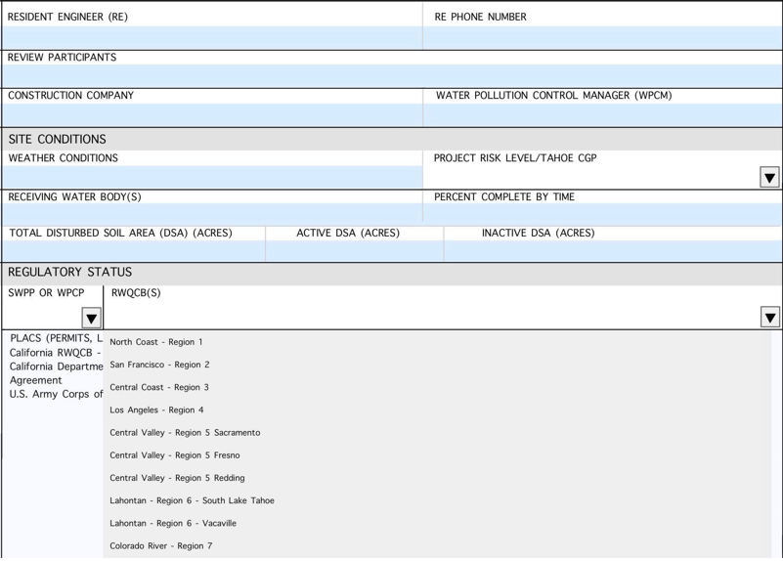

Figure 5.2: Dropbox including autofill from the CONSTRUCTION SITE BMP SUMMARY section

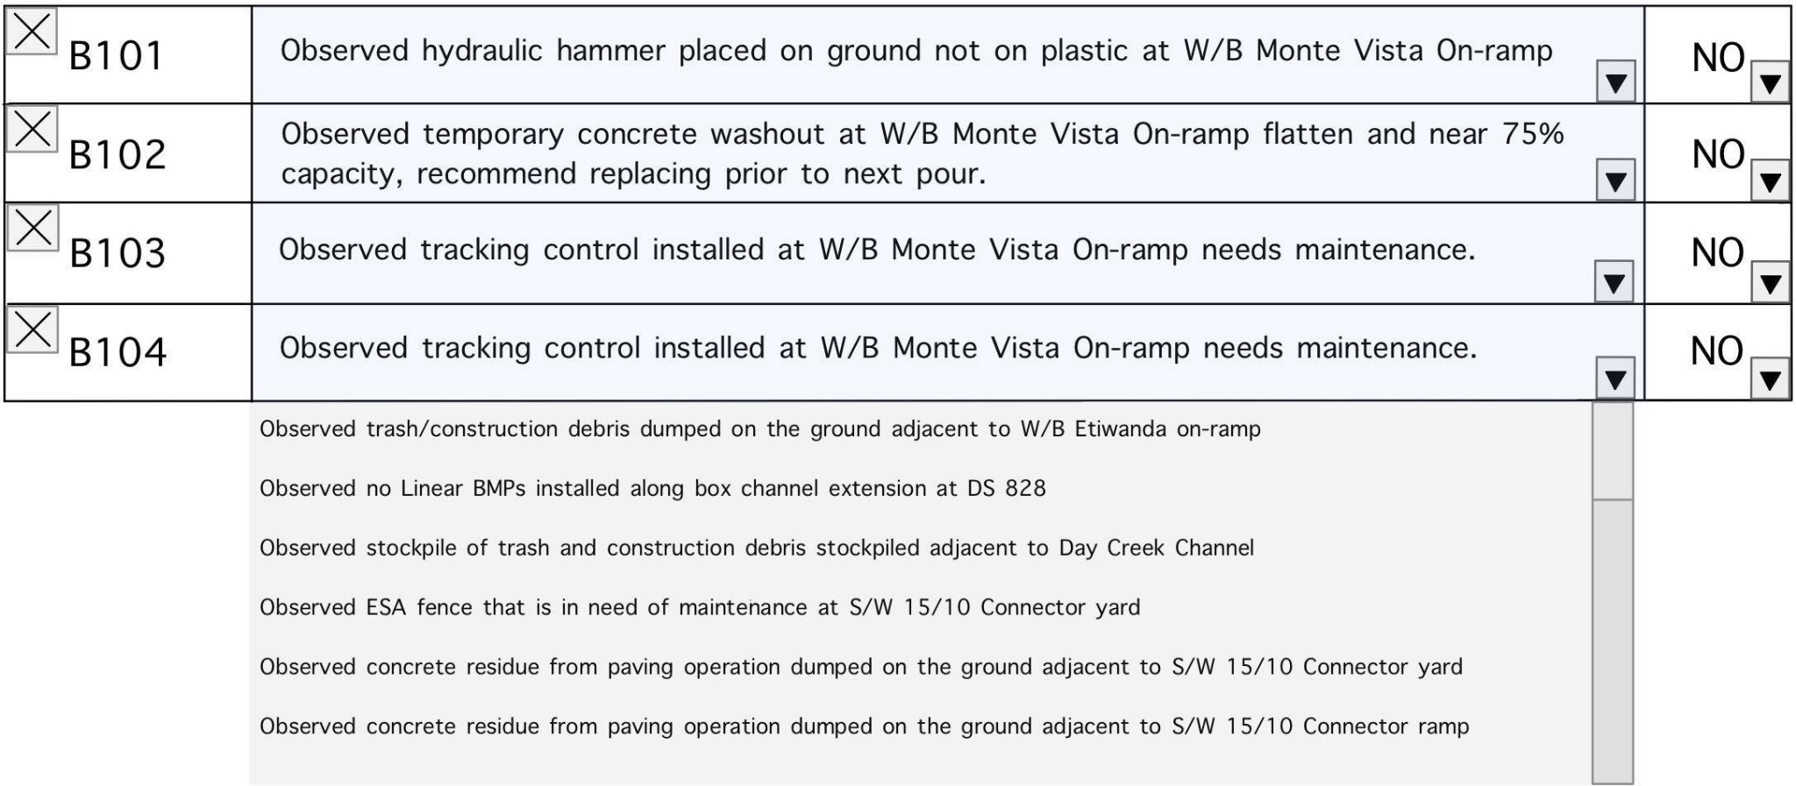

Figure 5.3: Inserting pictures into report

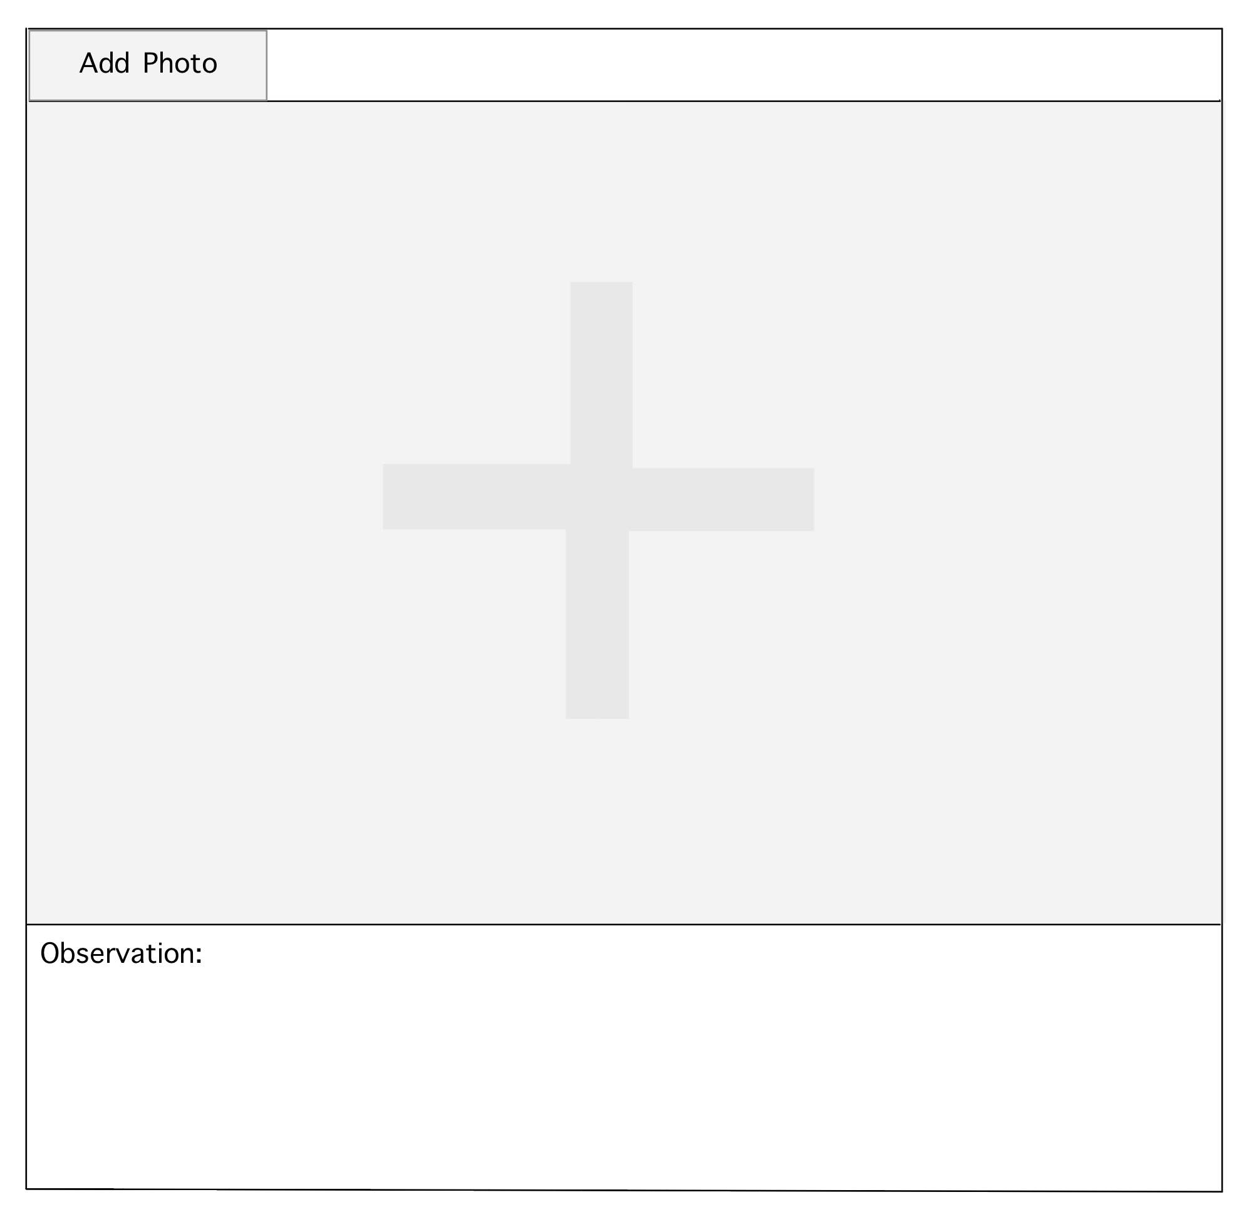

**6. General Constraints and Assumptions**

Constraints

* Time constraint: scheduling the project. Team members have different schedules.

Sometimes it is difficult to set up meeting times.

* Resource constraint: Team members, licensed software, or iOS equipment may be unavailable.
* Regulatory/ legislative constraint: Following CalTrans Terms of Service and Code of Conduct
* Policy constraint: Members are expected to complete their assigned work to the best of their ability.

Assumptions

* Skillset assumption: Team members have knowledge in a common language (Java).
* The team has the ability to complete a set of requirements in a given time frame.
* Team members have the required skills to complete the project.
* Members understand the general scope and expected deadlines of the project.

**7. Team Member Roles and Approval**

|  | Team Lead | SW Engineer | QoS Engineer | Technical Writer | Illustrator | Signatures |
| --- | --- | --- | --- | --- | --- | --- |
| Ryan | ✔ | ✔ | ✔ | ✔ |  | Ryan  Farruggia |
| Mahroona |  | ✔ | ✔ | ✔ |  | Mahroona |
| David |  | ✔ | ✔ |  |  | David Quintanilla |
| Bikram |  | ✔ | ✔ |  |  | Bikram  Singh |
| Tran |  | ✔ | ✔ |  |  | Tran Chi |
| Catalina |  | ✔ |  |  | ✔ |  |
| Raphael |  | ✔ |  |  | ✔ | Raphael Guerrero |

**Team Lead**: Overviews the team, organizes assignments, as well as instructs the group.

**SW Engineer**: Develops and evaluates computer software.

**QoS Engineer**: Provides strenuous testing to ensure the quality of product and that standards are met.

**Technical Writer**: Produces instructions through creating charts and other documents to communicate technical information.

**Illustrator**: Provides graphic design and illustrations for the project.